**GUI instructions, Employee Module – use cases a,b,g:**

A: Recruiting new employee to a role: (recruit employee, certify employee)

To recruit an employee, run the HRManager window by running the application with the string "GUI HRManager". Click the "Recruit Employee" button, fill in the employee details, and finally click "Submit".

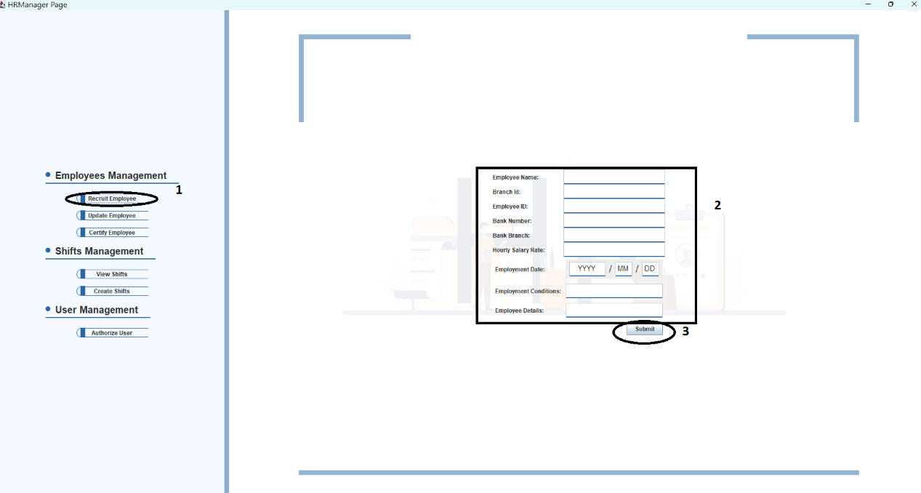

To certify that employee, click the "Certify Employee" button, fill in the employee's Id first and click "Find Employee Roles". Once found, his current certifications appear below. Choose the wanted roles to be certified or uncertified and press certify or uncertify accordingly.

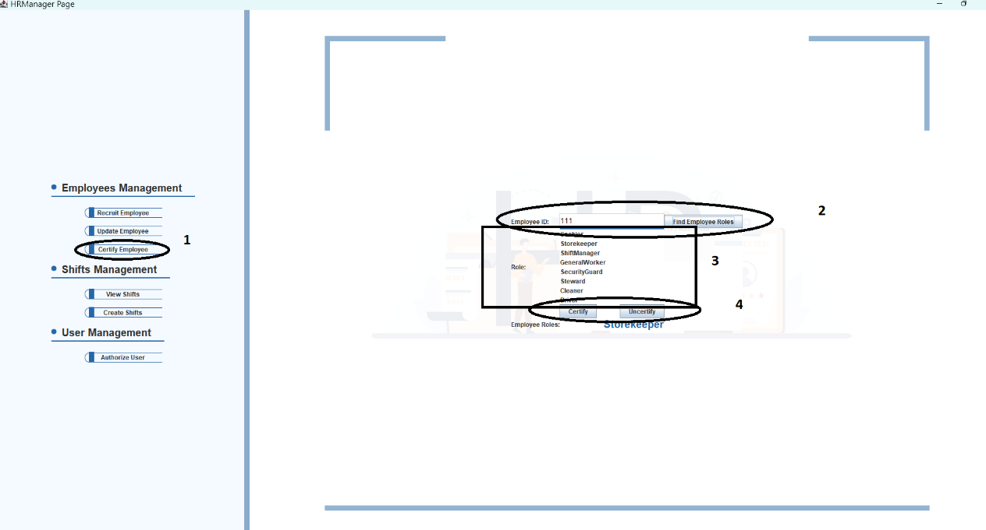

B: Update employee details and availability ( request shift, update details)

To request a shift as an employee, run the employee window with the string: "GUI Employee". Press request shift:

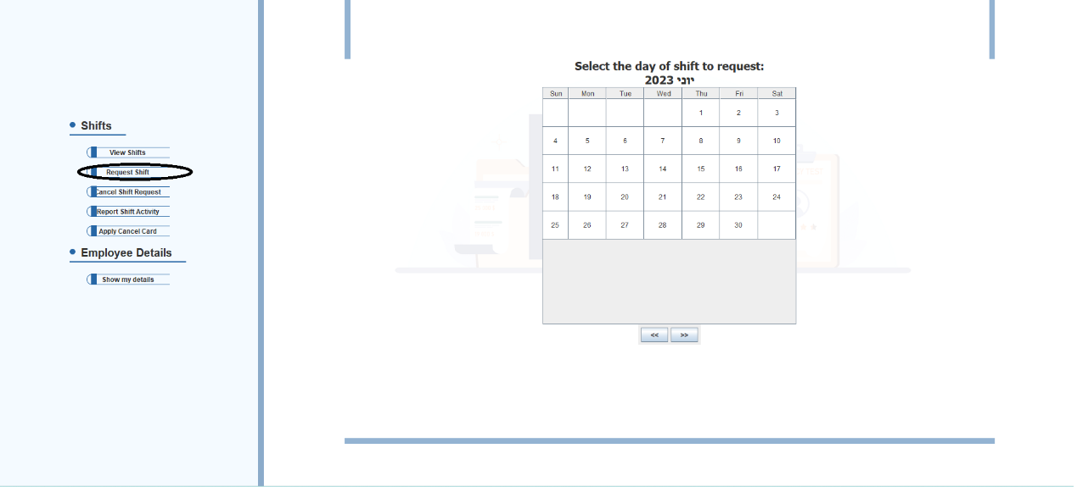

Choose a date (double click):

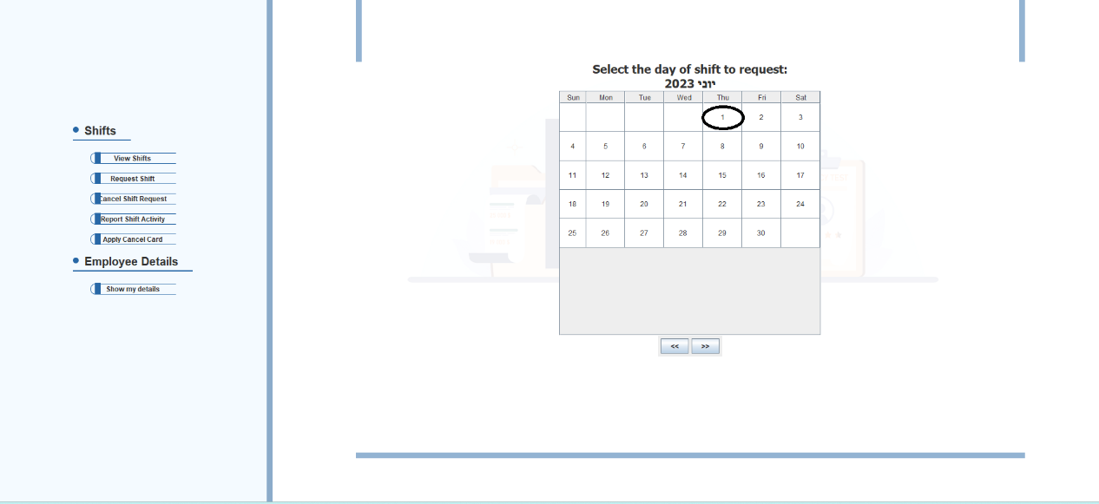

Choose a shift and click "Request Shift":

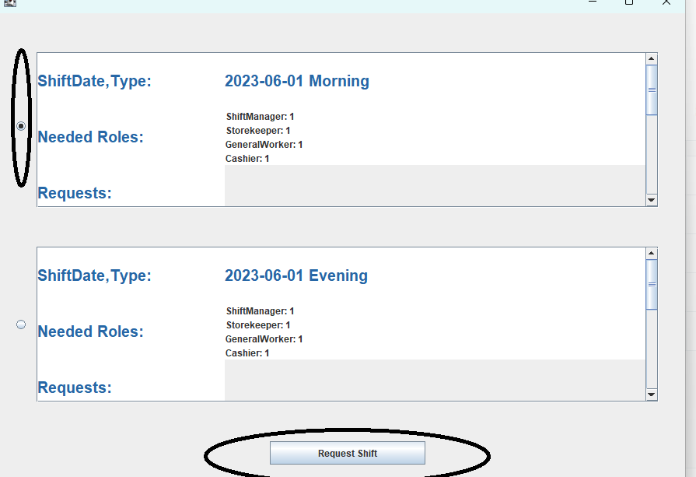

To update Employee details Run the HRManager menu by running the application with the string: "GUI HRManager". Click the "Update Employee" button, fill in the employee ID that is wished to be updated, and click "Find Employee". Once the employee is found, fill in the rest of the employee details as wished to be updated. When finished, press "Submit".

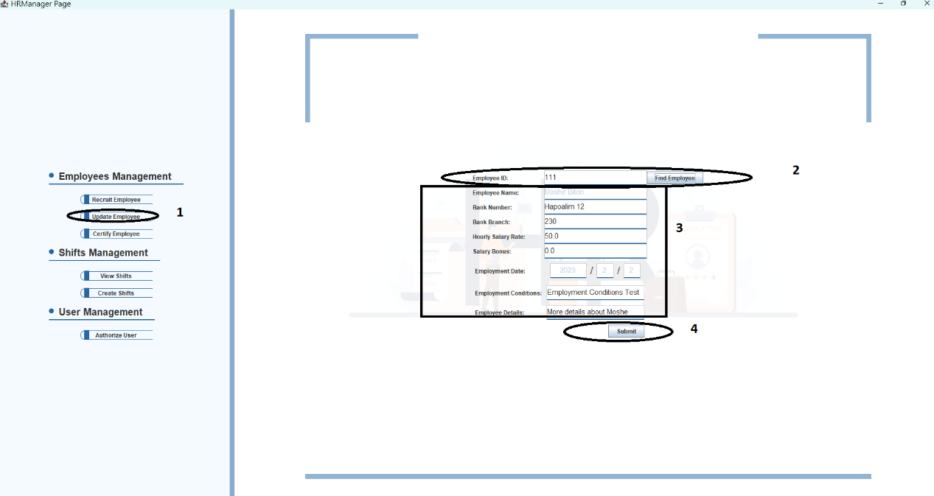

G: Assigining Employees to shifts

1.Certify an Employee(s) as described in use case A.

2. Create week shifts In the HRManager menu by clicking on "Create Shifts" button, choose a branch to create shifts for, select a date by double clicking, and click "yes" to create shifts for the whole week.

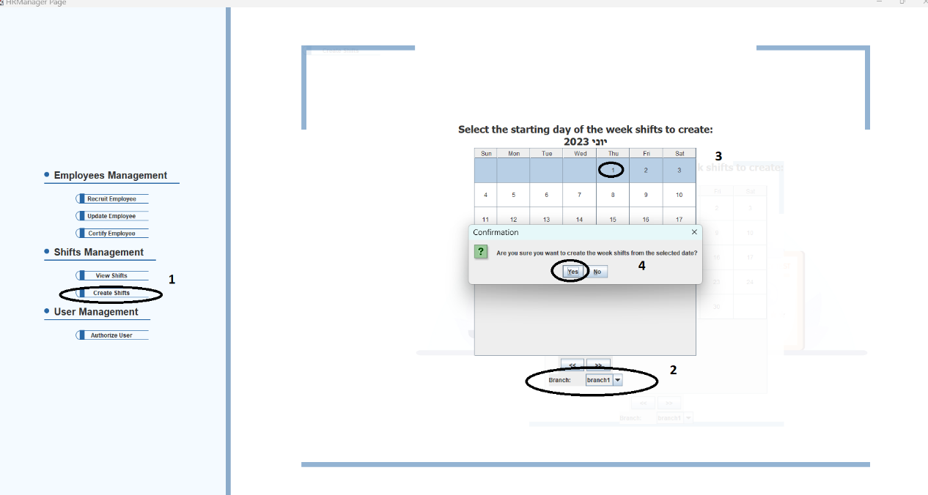

To specify particular needed roles for particular shifts and the amount of workers for each role, double click a particular date after it's shifts are created, a window will open, choose a shift, click "update", choose "Needed Roles" in the box and click "Ok".

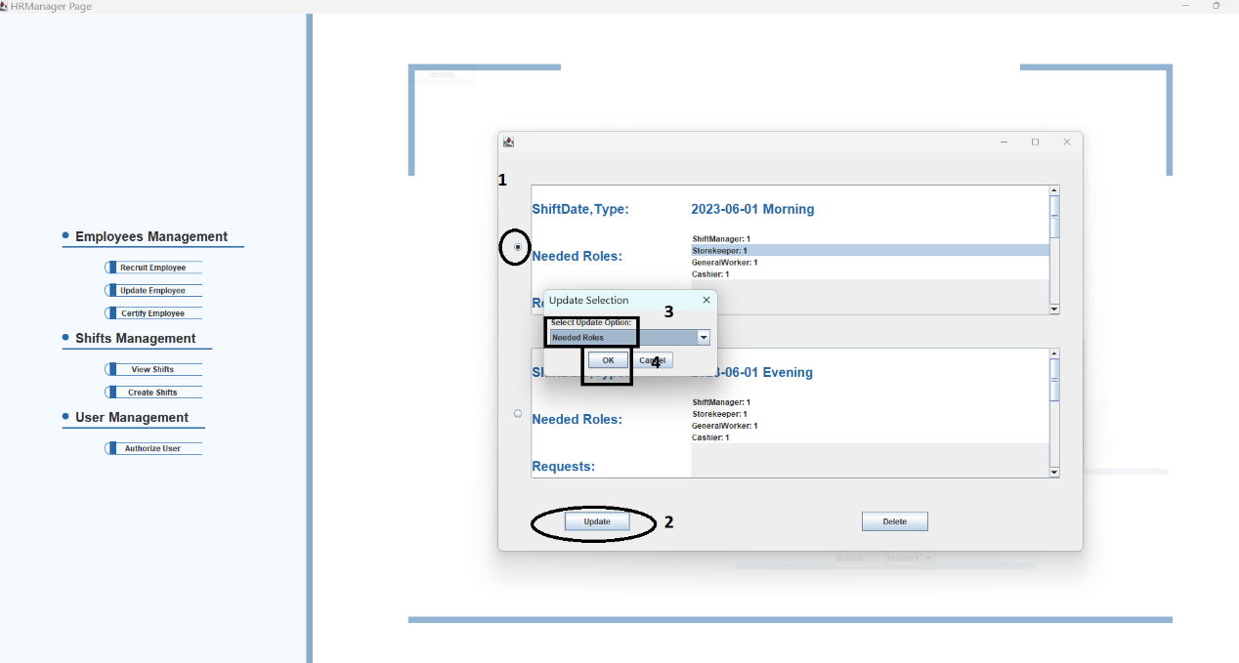

Update Option window will open. Click "Modify" to modify the amount of needed workers for an existing role in that shift. Click "Add" to add a new role for the shift. Click "Remove" to remove a role from the shift.

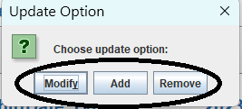

Choose the Shift to update/add/remove and click "OK".

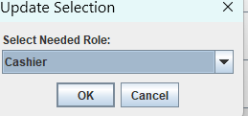

Insert the needed amount of workers for the chosen shift to be set, and click "OK".

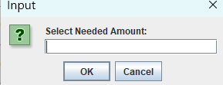

3+4.For the employee to choose his shifts, open the Employee menu by running the application with the string "GUI Employee" Click "Request Shift" and choose a date by double clicking it.

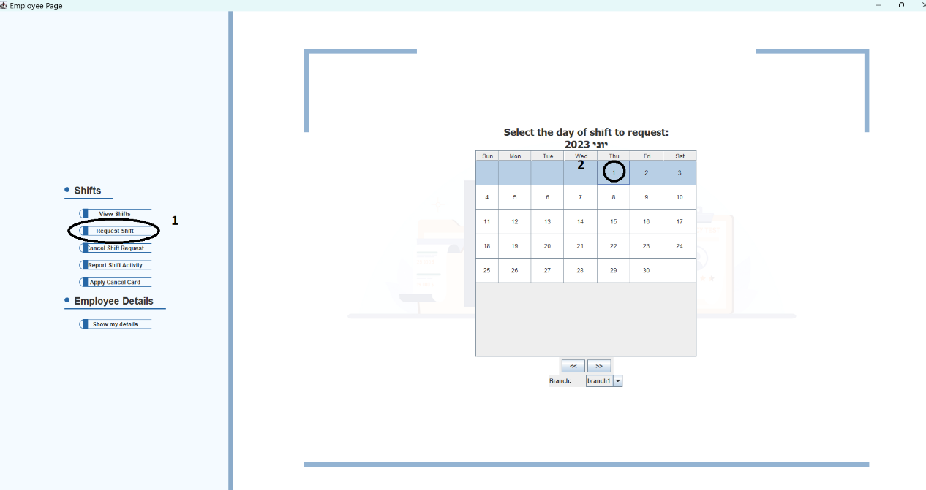Choose a shift to request, and click "Request Shift"

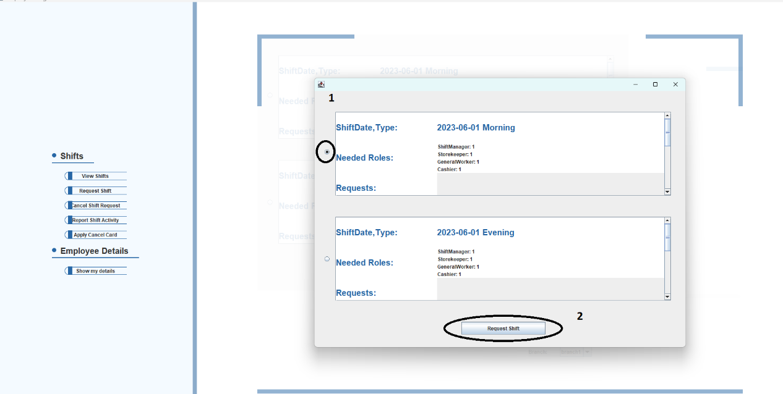

Choose a role to undertake in that shift, and click "Ok".



If the employee is not certified to do this role, the request won't be successful.

5.HR manager will get the employees' requests for shifts and roles. To register an employee to a shift he requested, run the HRManager menu, click "View Shifts", choose a branch, and choose a date and a shift as was done when setting needed roles.

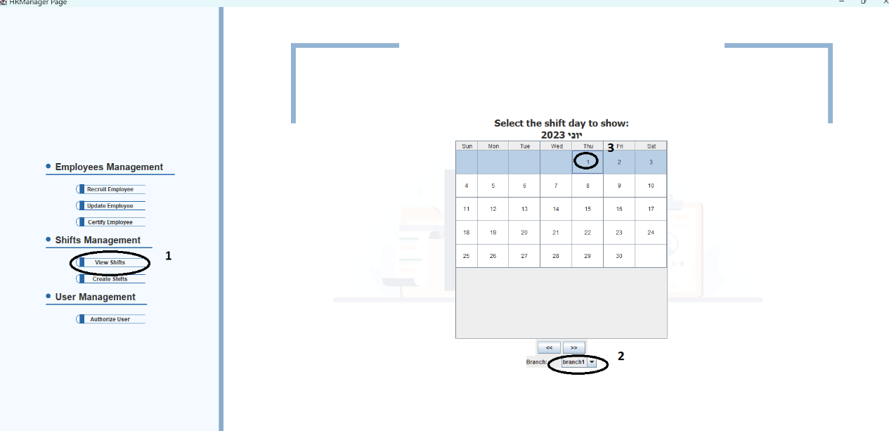

This time, choose "Shift Workers" and click "Ok".

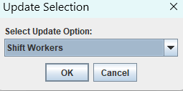

Click "Modify" to modify the shift, click "Add" to add employees to the shift, click "Remove" to remove registered employees from the shift.



When chosen "Add", choose a role to add employees.

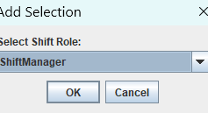

In the following window, all the requesting employees for the role will appear. Choose one of them by typing in the desired employee's id and click "Ok".

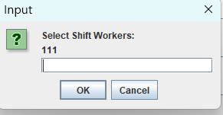

6.To verify shift:

As before, click "View shifts", choose a branch, date and shift, and select "Approve" in the box and click "Ok".

